Kinberg, Nicholas
Prof. Jennifer Moore
Introduction to GIS
29 November 2019
Low-Rent Buildings and Crime Locations in New York City
Problem and Hypothesis
New York City has succeeded in lowering crime levels since the 1980s. The administrations of Rudy Giuliani and Michael Bloomberg have done much to produce this result. But rising gentrification has pushed poverty to the geographic margins of the city, all while crime levels stagnate at these poor locations. The hypothesis of this project is that crime locations and low rent structures will be most prevalent in historically low-rent boroughs of New York City like Harlem.

Audiences
The audience of this project is the New York City government and the residents of poor communities in the City. With this data, the city’s administration can target poor and crime-ridden regions to lower crime and increase living standards.

Data Used
I used crime, building, and parcel data from NYC.gov Spatial Data, the USA Geocoding Service, and Columbia GIS Data. I put these data on a map with the WGS84(DD) coordinate system. I downloaded a map of New York City from Washington University’s GISPublic drive.
To supplement my policy analysis, I included peace research from my course “International Conflict Management and Resolution.” More specifically, I related my analysis to How Wars End and research from the Center for Strategic and International Studies (CSIS).

Methods and Steps
I stored relative pathways while working on my maps and connected Washington University’s GISPublic drive and my project folder structure to ArcMap. I collected data by scouring NYC.gov Spatial Data and Columbia GIS Data. I first narrowed my search to parcel data to find information on the structures in New York City. To find the parcel and building data sets, I used NYC.gov. NYC.gov is a better source at which to find crime statistics for the entire city, while Columbia GIS Data is optimal for finding crime statistics for Manhattan. To find a map of New York City, I searched on Washington University’s GISPublic drive. To put all data on the same plane, I used the WGS84(DD) coordinate system for both maps. I used CSV files and shapefiles, as well as a geodatabase I downloaded from NYC.gov, to visualize the data. To join the data, I used geocoding for the Manhattan data and an XY-join for the city data.
Then, I searched for crime statistics. I found Manhattan crime statistics published by the city’s administration for 2017-18, as well as crime statistics for all five boroughs. I created two maps, one of Manhattan and one of the entire city.
To find low-rent buildings near crime locations, I first selected by location the parcels and buildings 0.1 miles or closer to crime locations. I then exported the selected data and created a new layer for these items. I assumed that buildings with lower elevation correlated with lower rent. I assumed this because lower buildings are much more common in low-rent cities than high-rises. I then deleted all buildings with an elevation above 50 feet for both maps. Thus, my map only showed low-rent structures near crime locations.
After this, I created data frames for both maps, copying and pasting and emphasizing areas with high crime incidents. The map of Manhattan was much more useful for me because the data I found for Manhattan was more granular than for the entire city. As for the city, I found reams of data on Harlem, the Bronx, Queens, and Brooklyn. I used these facts to zoom in on areas with high amounts of crime, understood as areas with large clusters of green dots. I indicated buildings surrounding these green dots to show which structures might require more police protection.
After this, I inserted my own labels for the burroughs to make the city easier to identify for policy analysts unfamiliar with New York City. I used the draw tool to draw lines from the data frames emphasizing parts of the city to those parts’ correspondent greater maps. I added legends, scale bars for the parts of town I emphasized, north stars, source information, and scale bars.

Challenges
I still have difficulty mapping data onto maps. This is because I haven’t practiced doing this enough. Data on buildings and parcels didn’t include information on how much each parcel or building cost, unlike the information with which we worked to create maps on St. Louis City and County. To circumvent this challenge, I made the assumption described in the previous section.

Results
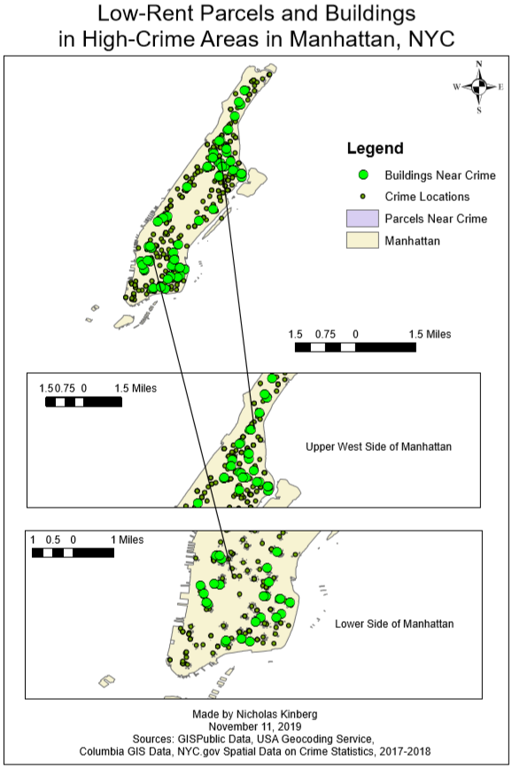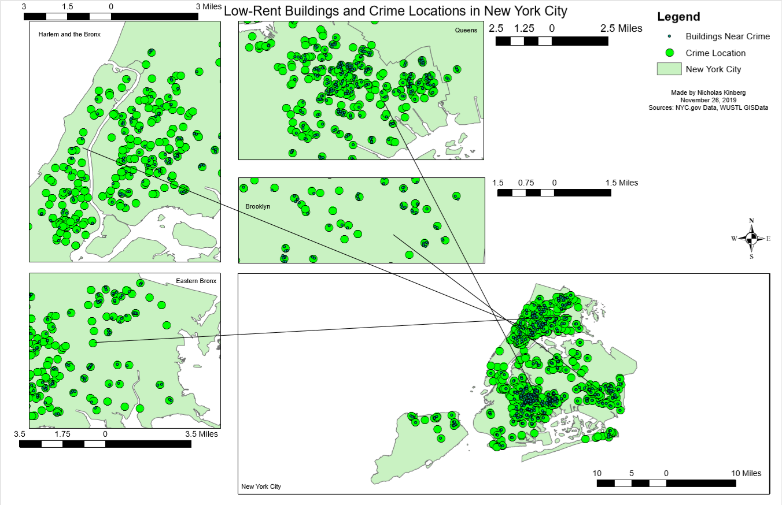
As demonstrated by these maps, the highest concentrations of crime and low-rent structures results in upper and lower Manhattan, Harlem and the Bronx, eastern Queens, and western Brooklyn. With this data, New York City’s administration should target these locations for increased police presence. Social workers and economists working for the city should also be dispatched to these locations to interview residents on economic grievances and living standards. These professionals should then produce a report by 2022 detailing economic grievances and recommendations to assuage these grievances.

Policy Recommendations
As with peace research, crime and the propensity of people to profit from predation decrease as the prevalence of third-party actors increases. People are unable to prey on each other if law enforcement provides an effective deterrent to initiating crime (Reiter, 2009). New York City’s government should increase police presence in far upper and lower Manhattan, in Harlem and the Bronx, in eastern Queens, and in western Brooklyn. Furthermore, these police units should form substantive relationships with their respective communities to root out crime.
From there, crime will dissipate and communities will strengthen, thus producing higher income (Cusack, 2013). These better lives will lead to the dissipation of poverty and increase the standard of living for the aforementioned locations in New York City.

Next Steps
This data presents an opportunity for New York City’s administration. The city should check on the increased police presence program one year after the program’s initiation. During this review, the administration should compare crime levels in 2021 to those in 2018. If crime levels are lower, the administration should continue the program and work with the targeted communities to address economic grievances. Then, the administration should produce a report on economic grievances in far upper and lower Manhattan, Harlem, the Bronx, eastern Queens, and western Brooklyn by 2022. Finally, the city should implement policy recommendations from that report to improve living standards in these locations.

Works Cited
Cusack, Jake, and Matt Tilleard. “Investment Facilitation in Transitional and Fragile States.”
Investment Facilitation in Transitional and Fragile States. Center for Strategic and International Studies, December 2013. https://csis-prod.s3.amazonaws.com/s3fs-public/legacy_files/files/publication/131213_Cusack_InvestmentFacilitation_Web.pdf.
Reiter, Dan. How Wars End. Princeton: Princeton University Press, 2009.

